**Name: Roma Shirodkar**

**Div: D15B**

**Roll No: 54**

**MPL & PWA Practical 7**

**Aim: To convert a React website into a Progressive Web App (PWA)**

### **1. Install Vite PWA Plugin**

1. Open the terminal in your **Vite** project folder.
2. Run the following command to install the **Vite PWA** plugin:

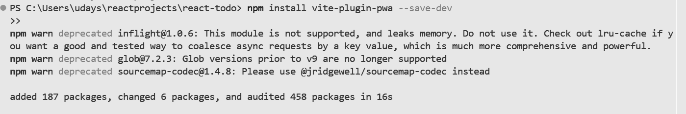

### **2. Configure Vite for PWA**

1. Open the **vite.config.js** (or **vite.config.ts** if using TypeScript).
2. Import the PWA plugin and add it to the plugins array:

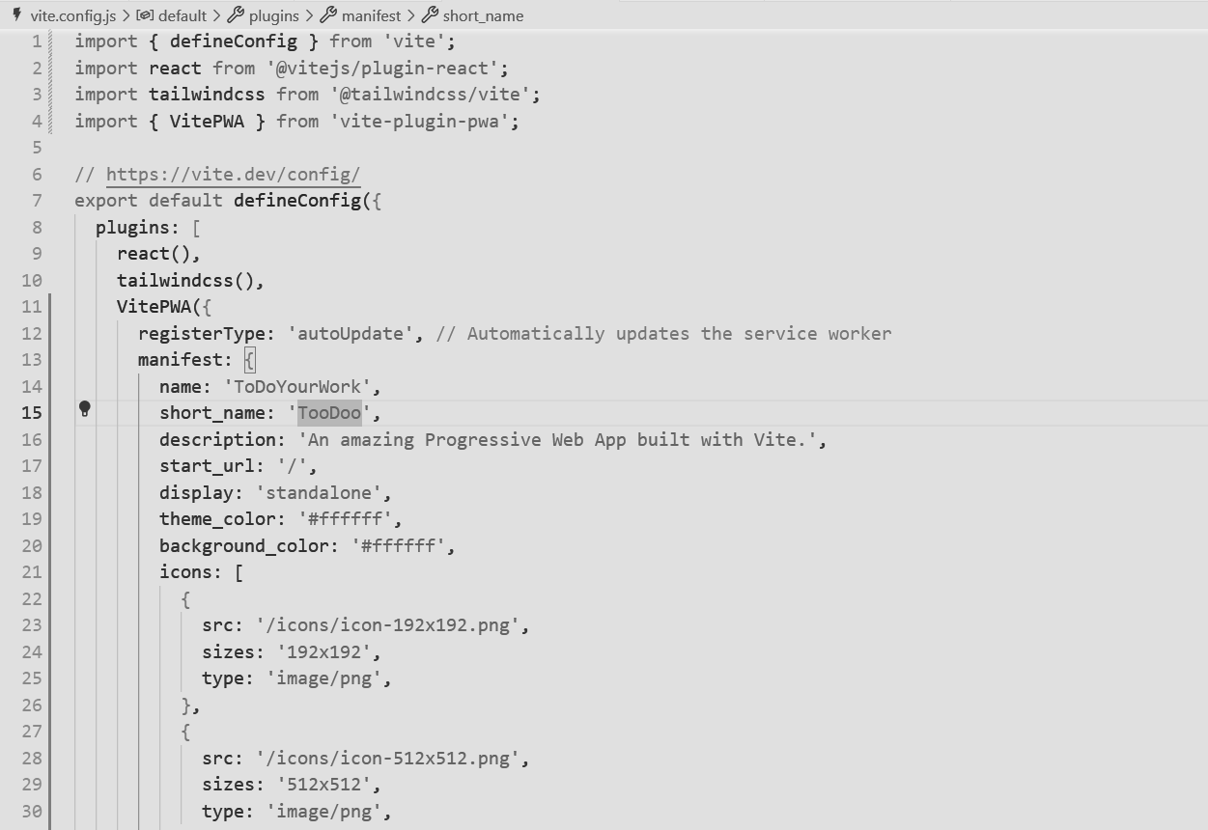

### **3. Add manifest.json File**

1. Navigate to the **public** folder in your Vite project.
2. Create a new file called **manifest.json** (if it doesn’t exist).
3. Add basic app information:

